http://bitsofwisdom.org/2009/10/21/interesting/perception/

« We are all connected
You’re making the future »

Perception
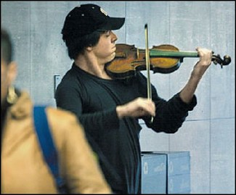
Something to think about….
Washington, DC Metro Station on a cold January morning in 2007. The man with a violin played six Bach pieces for about 45 minutes. During that time approximately. 2 thousand people went through the station, most of them on their way to work. After 3 minutes a middle aged man noticed there was a musician playing. He slowed his pace and stopped for a few seconds and then hurried to meet his schedule.
4 minutes later:
The violinist received his first dollar: a woman threw the money in the hat and, without stopping, continued to walk.
6 minutes:
A young man leaned against the wall to listen to him, then looked at his watch and started to walk again.
10 minutes:
A 3-year old boy stopped but his mother tugged him along hurriedly. The kid stopped to look at the violinist again, but the mother pushed hard and the child continued to walk, turning his head all the time. This action was repeated by several other children. Every parent, without exception, forced their children to move on quickly.
45 minutes:
The musician played continuously. Only 6 people stopped and listened for a short while. About 20 gave money but continued to walk at their normal pace. The man collected a total of $32.
1 hour:
He finished playing and silence took over. No one noticed. No one applauded, nor was there any recognition.
No one knew this, but the violinist was Joshua Bell, one of the greatest musicians in the world. He played one of the most intricate pieces ever written, with a violin worth $3.5 million dollars. Two days before Joshua Bell sold out a theater in Boston where the seats averaged $100.
This is a true story. Joshua Bell playing incognito in the metro station was organized by the Washington Post as part of a social experiment about perception, taste and people’s priorities.
The questions raised:
*In a common place environment at an inappropriate hour, do we perceive beauty?
*Do we stop to appreciate it?
*Do we recognize talent in an unexpected context?
One possible conclusion reached from this experiment could be this:
If we do not have a moment to stop and listen to one of the best musicians in the world, playing some of the finest music ever written, with one of the most beautiful instruments ever made.
How many other things are we missing?

